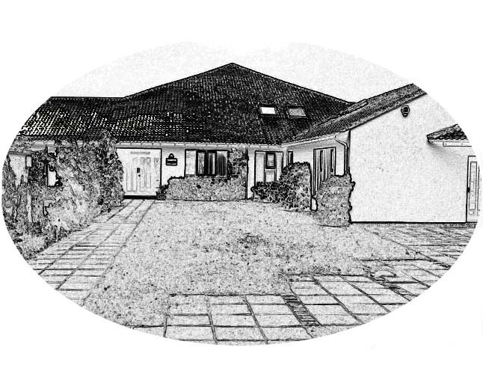
Haddenham Community Junior School
Woodways Haddenham Aylesbury Bucks HP17 8DS
Tel: 01844 291829 Fax: 01844 292534
Chair of Governors: Dr. D. Palmer Headteacher: Mrs. S. Lewin
E-mail: office@haddenham-jun.bucks.sch.uk Website: www.haddenham-jun.bucks.sch.uk
Registered Charity No. 1122813
Aiming High, Celebrating Success

Pupil Premium Statement
2012-13

For the academic year 2012-13 the school was in receipt of £9,109 for pupil premium.
This was spent as follows:

- Subsidising music lessons
- Subsidising educational visits, including residentials
- For LSA led support groups in Maths lessons
- For Teacher led booster groups in Maths

The children who are, or who have been entitled to Free School Meals are making comparable progress to their peers.

