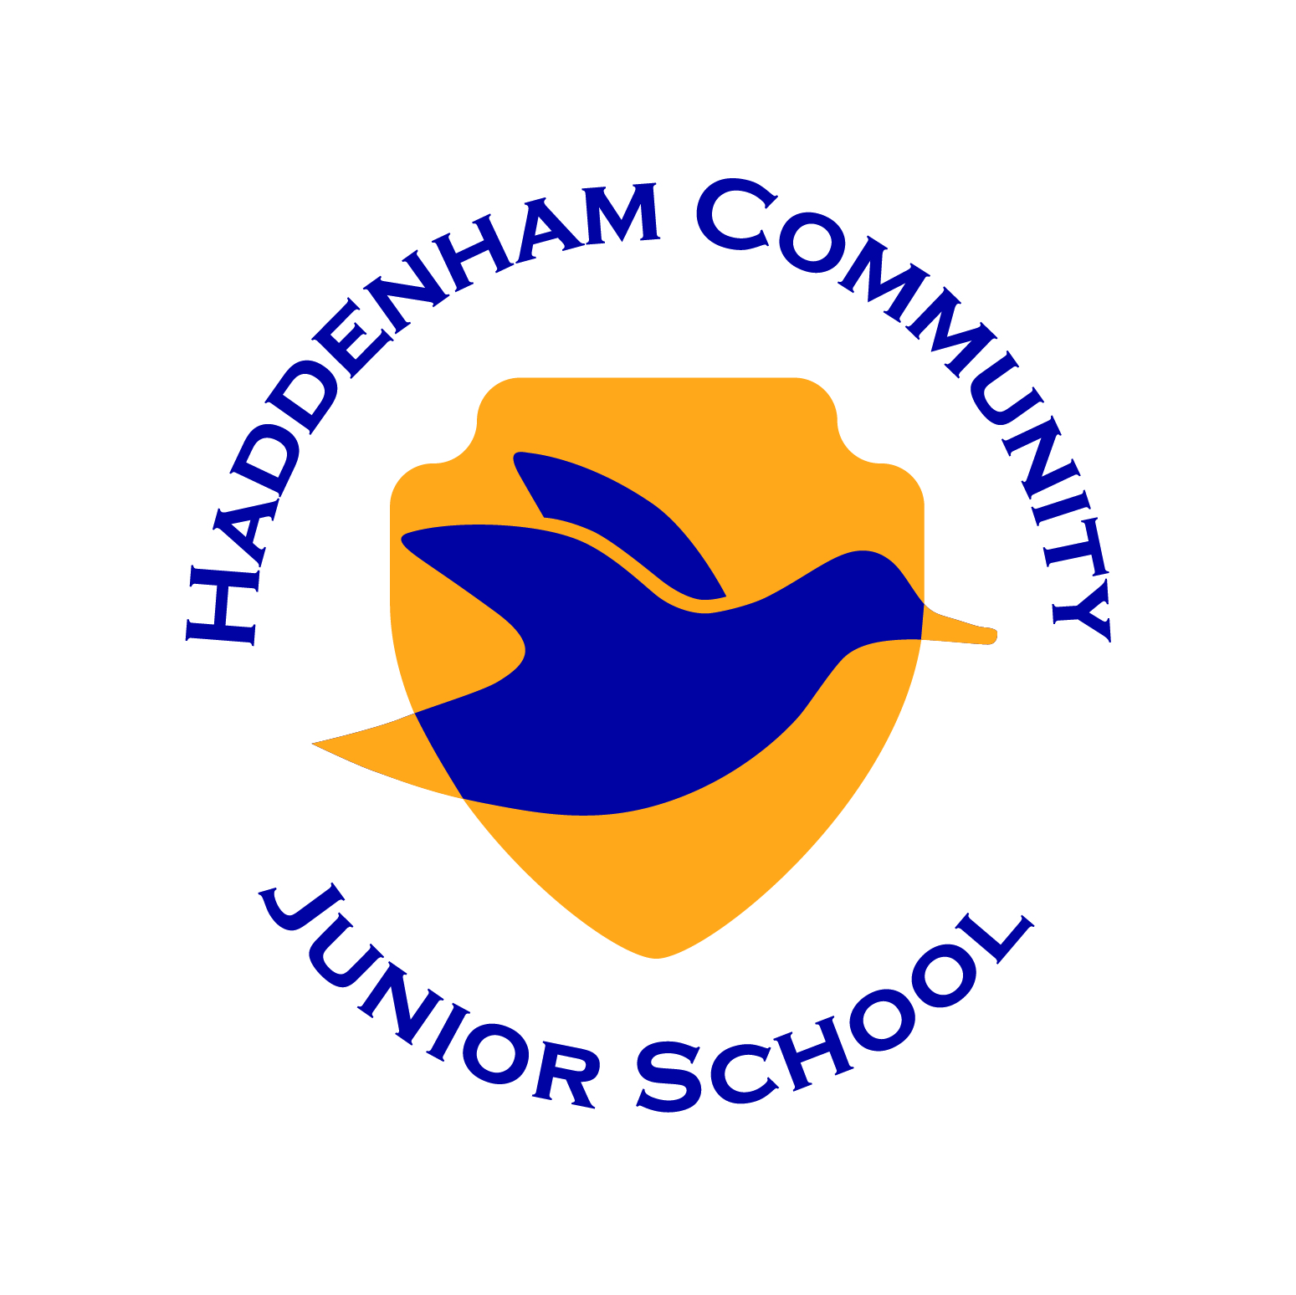
Woodways Haddenham Aylesbury
Bucks HP17 8DS
Tel: 01844 291829
Chair of Governors: Mrs. A Glasspool
Headteacher: Mr A. Leach
E-mail: office@haddenhamjun.co.uk

Dare to fall, learn to fly.

26th September 2023

Dear Parents,

Re: Hot meals for 2nd half of autumn term – Monday 30th October to Tuesday 19th December 2023 inclusive

We are now booking hot dinners for the next half-term, commencing Monday 30th October. Once again you can book your child a meal for either 3 or 5 days (please remember that these are a set 3 days on a Wednesday, Thursday and Friday and cannot be changed).

Years 3 have one trip planned for next half-term. Therefore, if you would like to book for the full 5 days per week the children will have a hot meal for a total of 36 days, the price will be 98.64. If you would like to book a hot meal for just 3 days a week (Weds, Thurs, Fri), the children will have a hot dinner for a total of 21 days, and the price will be £57.54.

Years 4 and 5 have no trips planned for next half-term. Therefore, if you would like to book for the full 5 days per week the children will have a hot meal for a total of 37 days, the price will be £101.38 If you would like to book a hot meal for just 3 days a week (Weds, Thurs, Fri), the children will have a hot dinner for a total of 21 days, and the price will be £57.54.

Years 6 have one trip planned for next half-term. Therefore, if you would like to book for the full 5 days per week the children will have a hot meal for a total of 36 days, the price will be 98.64. If you would like to book a hot meal for just 3 days a week (Weds, Thurs, Fri), the children will have a hot dinner for a total of 20 days, and the price will be £54.80.

Payment for all hot meals should be made on-line using ParentPay. Once you have logged into your account, there will be two payment options available for hot dinners, either 3 or 5 days. Please choose ONE option and follow the payment instructions. Any food allergies or vegetarian meals must be advised in the box marked ‘notes’ even if they’ve been reported previously. If your child has no food allergies, please state ‘NONE’. Payments cannot be processed without this information. If you have any problems with activating your ParentPay account or need any assistance, please contact the school office.

If you are entitled to Free School Meals you do not need to order through ParentPay so please complete and return the reply slip herewith. FREE SCHOOL MEALS are not ordered without the reply slip.

Please note that the deadline for all orders and payment is Sunday 8th October 2023. Unfortunately orders received after this date are unable to be processed. Please note that in the event of your child being absent from school we are unable to refund any hot school dinners.

Yours faithfully,

Andy Leach

Headteacher

For completion ONLY if your child is entitled to Free School Meals

Hot Meals – Autumn Term (Part 2)2023

I would like my child …………………………………………………… Class ………… to have a hot meal.

My booking is for 3 days per week (Weds, Thurs and Fri only)

My booking is for 5 days per week

My child is a vegetarian Yes / No delete as appropriate
Please note the Vegetarian option will be served EVERY DAY if this is requested.

Please detail any allergies (even if they have been reported previously):

Parent’s Name ……………………………………………………………………………………………………….

Signature …………………………………………………………………………………. Date …………………………

